Shopping Mall Customer Segmentation Analysis
Prepared By: Himanshu Pandey
Date: 03 May, 2026

1. Introduction

1.1 Project Background
Modern retail environments generate large volumes of customer data. However, without structured analysis, organizations struggle to convert this data into actionable business insights.
This project focuses on analysing shopping mall customer data to understand purchasing behaviour and identify meaningful customer segments. The objective is to enable data-driven marketing strategies that improve customer engagement, retention, and revenue performance.

1.2 Project Objectives
The primary objectives of this project are:
- Clean and prepare customer data for analysis
- Understand demographic and spending behaviour
- Segment customers based on income and spending patterns
- Develop an interactive business dashboard
- Provide strategic business recommendations

1.3 Business Problem
Shopping malls often apply uniform marketing strategies to all customers. This results in:
- inefficient marketing spends
- poor customer engagement
- missed revenue opportunities
Customer segmentation enables targeted decision-making by identifying groups with similar behavioural characteristics.

2. Dataset Overview

2.1 Dataset Description
The dataset contains customer-level information including:
Variable | Description
Customer ID | Unique customer identifier
Age | Customer age
Gender | Male/Female classification
Annual Income | Customer yearly income
Spending Score | Purchasing behaviour indicator

Total Records: 15,079 customers

2.2 Data Cleaning & Preparation
The following preprocessing steps were performed:
- Verified dataset structure
- Checked missing values
- Removed duplicate entries
- Standardized column naming
- Converted data types appropriately
- Created derived analytical features
No missing or duplicate records were identified, confirming strong data quality.

2.3 Feature Engineering
Two additional analytical variables were created:
Age Groups
Customers were grouped into business-friendly age ranges:
- 18–25
- 26–35
- 36–45
- 46–55
- 56–65
- 66–75
- 76–90
Boundary validation ensured that minimum age values were properly included.

Customer Segments
Customers were classified into four strategic segments:
- High Income – High Spending
- High Income – Low Spending
- Low Income – High Spending
- Low Income – Low Spending

3. Exploratory Data Analysis

3.1 Customer Demographics
Analysis revealed:
- Average customer age ≈ 54 years
- Balanced gender representation
- Wide income distribution across customers
This indicates a mature and stable customer base.

3.2 Spending Behaviour Analysis
Key observations:
- Average spending score ≈ 51
- Spending behaviour varies independently from income level
- Both high and low income customers demonstrate diverse purchasing habits

3.3 Gender-Based Insights
Spending behaviour across genders was nearly equal, suggesting:
- marketing campaigns should remain gender-neutral
- behavioural segmentation is more valuable than demographic targeting

3.4 Age-Based Analysis
Spending behaviour remained relatively consistent across age groups, indicating:
- lifestyle and engagement factors influence purchases more than age alone.

3.5 Income vs Spending Relationship
Correlation analysis showed minimal relationship between income and spending score.
Business Interpretation:
Higher income does not automatically translate into higher spending behaviour.

4. Customer Segmentation Analysis
Customer segmentation formed the core analytical component of this project.

4.1 Segmentation Logic
Customers were classified using mean income and mean spending score thresholds.
This produced four balanced customer clusters.

4.2 Segment Distribution
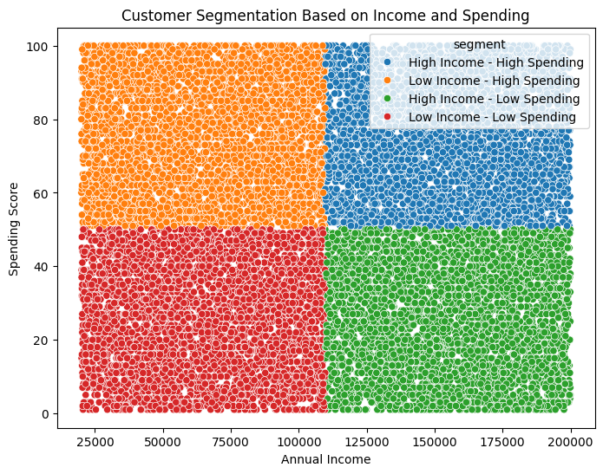
Each segment contained a comparable number of customers, ensuring meaningful comparative analysis.

4.3 Segment Characteristics
High Income – High Spending
- Premium customers
- Strong purchasing behaviour
- Primary revenue contributors
High Income – Low Spending
- High purchasing capacity
- Under-engaged customer group
- Major growth opportunity
Low Income – High Spending
- Value-driven customers
- Responsive to promotions
Low Income – Low Spending
- Low engagement level
- Long-term development segment

4.4 Data Validation Checks
Professional validation steps were performed:
- Record count verification
- Age group completeness validation
- Segment assignment verification
- Missing value confirmation
- Logical range checks
These checks ensured analytical reliability before dashboard creation.

5. Interactive Dashboard Development
An interactive Power BI dashboard was developed to communicate insights visually.

5.1 Dashboard Objectives
The dashboard enables stakeholders to:
- explore customer demographics
- understand spending patterns
- evaluate customer segments
- support data-driven decisions

5.2 Dashboard Components
Gender-wise Customer Distribution
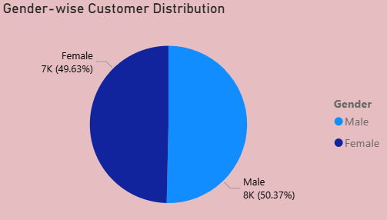
Displays gender composition of the customer base.

Age-wise Customer Analysis
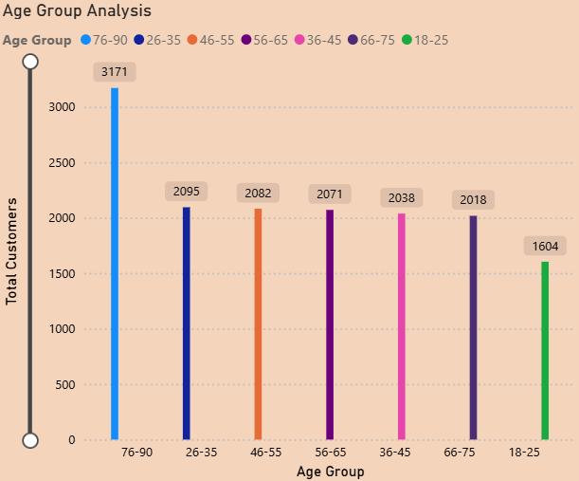
Highlights dominant customer age groups.

Income vs Spending Scatter Plot

(Insert Image Placeholder — Scatter Plot)
Primary analytical visualization showing behavioural clusters and validating segmentation.

Segment-wise Distribution
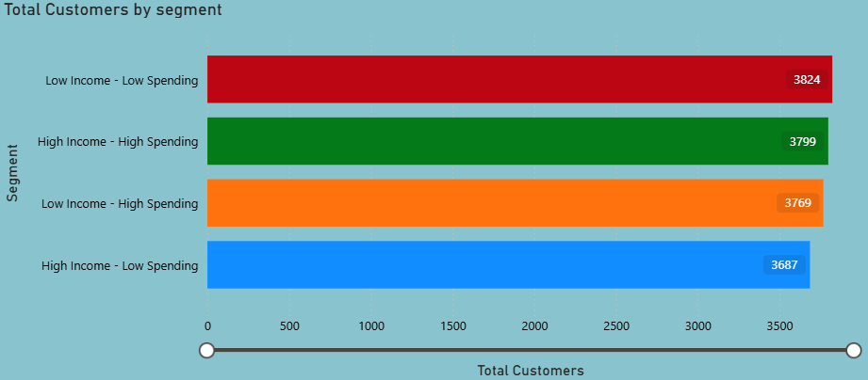
Shows relative size of each customer segment.

5.3 Dashboard Interactivity
Interactive slicers allow filtering by:
- Gender
- Age Group
- Customer Segment
This enables real-time business exploration.

6. Business Insights & Recommendations

6.1 Target Segment Priority
The organization should prioritize High Income – High Spending customers.

Recommended Actions
- VIP loyalty programs
- Exclusive experiences
- Personalized marketing
Expected Outcome
Higher retention and stable revenue growth.

6.2 Activating Low-Spending Customers
Low-spending customers represent conversion potential.
Recommended Strategies
- Discounts and promotional campaigns
- Bundle pricing
- Reward programs
- Seasonal marketing events
Expected Outcome
Increased engagement and transaction frequency.

6.3 Retaining High-Income Customers
Retention strategies should emphasize experience rather than pricing.
Recommended Strategies
- Personalized recommendations
- Early product access
- Exclusive events
- Premium services
Expected Outcome
Improved customer lifetime value.

6.4 Strategic Business Implications
Key organizational learnings include:
- Behavioural segmentation is more powerful than demographic segmentation.
- Customer engagement drives spending more than income level.
- Data analytics enables efficient allocation of marketing resources.

7. Business Value Delivered
This project demonstrates how structured analytics transforms raw customer data into strategic business intelligence.
Delivered outcomes include:
- Data-driven customer segmentation
- Interactive decision-support dashboard
- Actionable marketing recommendations
- Improved strategic planning capability

8. Conclusion
Through systematic data cleaning, exploratory analysis, customer segmentation, and dashboard visualization, this project provides a comprehensive understanding of customer behaviour within a retail environment.
Adopting segmentation-driven strategies enables the shopping mall to transition toward a customer-centric operating model, improving profitability while enhancing customer satisfaction.

9. Future Scope
Potential extensions of this analysis include:
- Machine learning–based clustering models
- Customer lifetime value prediction
- Personalized recommendation systems
- Real-time dashboard integration with transaction systems

